 | 26.9.9 Editors - Properties Editor - Modifiers Properties Tab - Grease Pencil - Deform Modifiers
Table of content
Detailed table of content 1
Deform modifiers 6
Armature 6
Hook 8
Lattice 10
Noise 11
Offset 14
Shrinkwrap 17
Smooth 20
Thickness 22

Detailed table of content

Detailed table of content
Detailed table of content 1
Deform modifiers 6
Armature 6
Apply ( Active Keyframe) 6
Apply ( All Keyframes) 6
Apply as Shape Key 6
Save as Shape Key 6
Object 6
Vertex Group 6
Invert 7
Bind to 7
Vertex Groups 7
Bone Envelopes 7
Hook 8
Object 8
Vertex Group 8
Invert 8
Strength 8
Reset 8
Recenter 8
Select 8
Assign 8
Falloff 9
Type 9
Radius 9
Uniform Falloff 9
Influence subpanel 9
Layer 9
Invert 9
Layer Pass 9
Use Layer pass 9
Layer pass value 9
Invert 9
Material 9
Invert 9
Material Pass 9
Use Material pass 10
Material pass value 10
Invert 10
Lattice 10
Object 10
Strength 10
Influence subpanel 10
Layer 10
Invert 10
Layer Pass 10
Use Layer pass 10
Layer pass value 10
Invert 11
Material 11
Invert 11
Material Pass 11
Use Material pass 11
Material pass value 11
Invert 11
Noise 11
Position 11
Strength 11
Thickness 11
UV 11
Noise Scale 11
Noise Offset 12
Noise Seed 12
Randomize 12
Step 12
Influence subpanel 12
Layer 12
Invert 12
Layer Pass 12
Use Layer pass 12
Layer pass value 12
Invert 12
Material 12
Invert 12
Material Pass 12
Use Material pass 13
Material pass value 13
Invert 13
Custom Curve 13
Navigation elements 13
Zoom in and out 13
Clipping 13
Tools 13
Reset View 13
Extend Horizontal 13
Extend Vertical 13
Reset Curve 13
Curve window 14
Vector Handle 14
Auto Handle 14
Auto Clamped Handle 14
X / Y 14
Delete Points 14
Offset 14
General Subpanel 14
Location X, Y, Z 14
Rotation X, Y, Z 14
Scale X, Y, Z 14
Advanced Subpanel 15
Mode 15
Random 15
Layer 15
Stroke 15
Material 15
Offset 15
Rotation 15
Scale 15
Uniform Scale 15
Seed 15
Layer Step 15
Layer Offset 15
Stroke Step 15
Stroke Offset 15
Material Step 16
Material Offset 16
Influence subpanel 16
Layer 16
Invert 16
Layer Pass 16
Use Layer pass 16
Layer pass value 16
Invert 16
Material 16
Invert 16
Material Pass 16
Use Material pass 16
Material pass value 16
Invert 17
Shrinkwrap 17
Wrap Method 17
Nearest Surface Point + Target Normal Project 17
Snap Mode 17
Target 17
Project 17
Snap Mode 17
Limit 18
Subdivision Levels 18
Axis 18
Negative/Positive 18
Face Cull 18
Invert Cull 18
Target 18
Auxiliary Target 18
Nearest Vertex 18
Target 18
Offset 18
Smooth factor 18
Repeat 19
Vertex Group 19
Invert 19
Influence subpanel 19
Layer 19
Invert 19
Layer Pass 19
Use Layer pass 19
Layer pass value 19
Invert 19
Material 19
Invert 19
Material Pass 19
Use Material pass 19
Material pass value 20
Invert 20
Smooth 20
Mode 20
Position 20
Strength 20
Thickness 20
UV 20
Factor 20
Repeat 20
Keep Shape 20
Smooth Ends 20
Influence subpanel 21
Layer 21
Invert 21
Layer Pass 21
Use Layer pass 21
Layer pass value 21
Invert 21
Material 21
Invert 21
Material Pass 21
Use Material pass 21
Material pass value 21
Invert 21
Thickness 22
Uniform Thickness 22
Thickness Factor 22
Weighted 22
Influence subpanel 22
Layer 22
Invert 22
Layer Pass 22
Use Layer pass 22
Layer pass value 22
Invert 22
Material 22
Invert 22
Material Pass 22
Use Material pass 23
Material pass value 23
Invert 23
Custom Curve 23
Navigation elements 23
Zoom in and out 23
Clipping 23
Tools 23
Reset View 23
Extend Horizontal 23
Extend Vertical 23
Reset Curve 23
Curve window 24
Vector Handle 24
Auto Handle 24
Auto Clamped Handle 24
X / Y 24
Delete Points 24

Deform modifiers
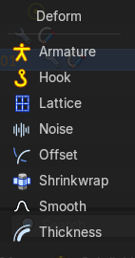

Armature
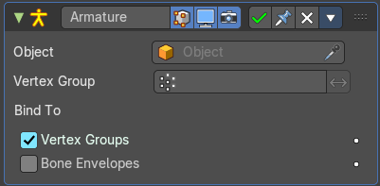
An armature system allows to deform objects accurately by posing bones. The Armature modifier contains the armature settings at the mesh end.
This modifier gets created automatically when you parent a grease pencil to an armature.

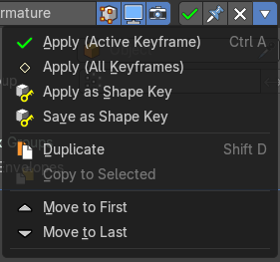
The armature modifier has some extra entries in the dropdown menu in the header.

Apply ( Active Keyframe)
Applies the active keyframe.

Apply ( All Keyframes)
Applies all keyframes.

Apply as Shape Key
Apply the modifier as a new shapekey to the mesh, and remove the armature modifier.

Save as Shape Key
Apply the modifier as a new shapekey to the mesh, but keep the armature modifier.

Object
The name of the armature object used by this modifier.

Vertex Group
A vertex group of the object, which weights will be used to determine the influence of this modifier’s results when mixing it with the results from other Armature ones.
This is only of use when having at least two of these modifiers on the same object, with Multi Modifier activated.

Invert
Inverts the influence set by the vertex group.

Bind to

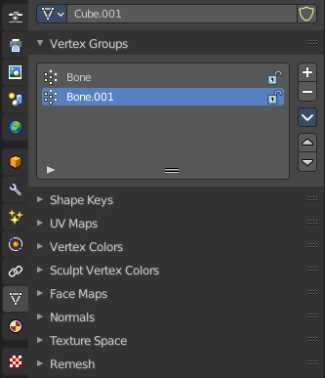
Vertex Groups
Meshes and lattices only. Use Vertex groups for deforming the mesh. A bone named “forearm”, will only affect the vertices in the “forearm” vertex group. The influence of one bone on a given vertex is controlled by the weight of this vertex in the relevant group.
The vertex groups are located in the Object Data Properties in the Properties editor.

Bone Envelopes
Use the Bone envelopes to deform vertices or control points near them, defined by each bone’s envelope radius and distance.
When envelopes are disabled, Blender uses the set of existing vertex group names to determine which bones influences what mesh part.
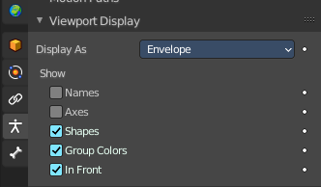
Bone envelopes display can be turned on in the Viewport Display panel in the Object Data properties tab in the Properties Editor. Display as ...

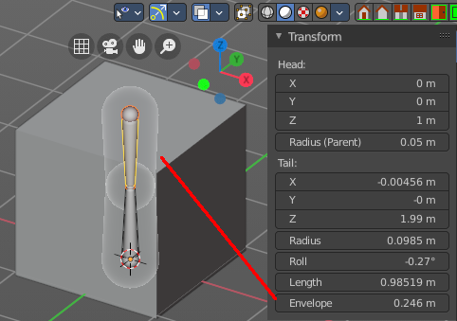
And can be adjusted in the Transform panel in the sidebar of the 3D View, in Edit mode.

Hook
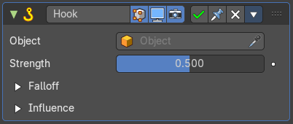
The Hook modifier is used to deform a mesh, curve or lattice by another object. When you move this hook object, then it pulls vertices or control points with it.
Assigning the hook object to specific vertices of the target object is done in Edit mode. The modifier shows a set of buttons then.
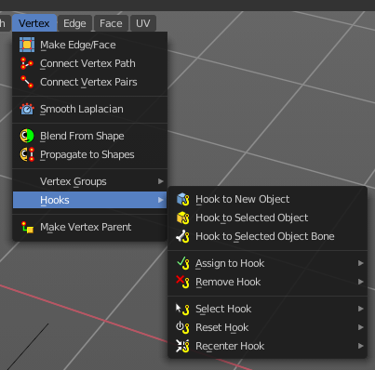
This modifier is automatically created when you add a Hook from the Hooks menu in the Edge menu in edit mode.
Some settings just exists in Edit mode.
Warning! The Hook Modifier stores vertex indices from the original mesh to determine what to affect. Modifiers that generate geometry, like Subdivision Surface, should always be put after the Hook modifier in the stack. Otherwise, the generated geometry can‘ t be affected by the hook’s influence.

Object
The name of the object to hook vertices to.

Vertex Group
Allows you to define the influence per vertex.

Invert
Inverts the influence of the selected vertex group.

Strength
Adjust this hooks influence on the vertices.

Reset
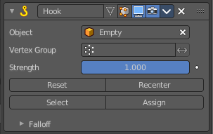
In Edit mode. Recalculate and clear the offset transform of the hook.

Recenter
In Edit mode. Set the hook center to the 3D cursor position.

Select
In Edit mode. Select the vertices affected by this hook.

Assign
In Edit mode. Assigns selected vertices to this hook.

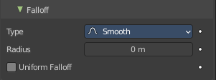
Falloff

Type
This can be used to adjust the kind of influence curve that the hook has on the mesh. You can also define a custom curve to get a much higher level of control.

Radius
The size of the hooks influence.

Uniform Falloff
Compensate non uniform scale, and use a uniform falloff.

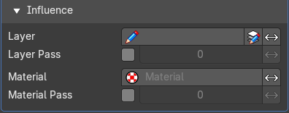
Influence subpanel

Layer
Restricts the effect only to one layer or to any layers that share the same pass index. Click to pick the layer that you want to use.

Invert
Inverts the influence.

Layer Pass
The layer pass index.

Use Layer pass
Use the layer pass.

Layer pass value
The layer pass value.

Invert
Inverts the influence.

Material
Restricts the effect only to material that share the same material or pass index. Click to pick the material that you want to use.

Invert
Inverts the influence.

Material Pass
The material pass index.

Use Material pass
Use the Material pass.

Material pass value
The Material pass value.

Invert
Inverts the influence.

Lattice
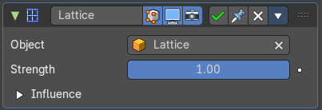
The Lattice modifier deforms the base object by the shape of a Lattice object. It can be used at meshes, curves, surfaces, text, lattices and even particles.
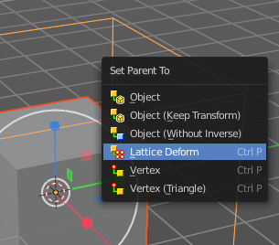
A Lattice modifier with valid settings can be added by selecting the object, holding down shift, select the target lattice object, and then choose Lattice Deform in the Parent menu.
Note! When you want to use a lattice to deform particles, then you need to place the Lattice modifier after the Particle System modifier.

Object
The Lattice object that deforms the base object.

Strength
A factor to control blending between original and deformed vertex positions.

Influence subpanel

Layer
Restricts the effect only to one layer or to any layers that share the same pass index. Click to pick the layer that you want to use.

Invert
Inverts the influence.

Layer Pass
The layer pass index.

Use Layer pass
Use the layer pass.

Layer pass value
The layer pass value.

Invert
Inverts the influence.

Material
Restricts the effect only to material that share the same material or pass index. Click to pick the material that you want to use.

Invert
Inverts the influence.

Material Pass
The material pass index.

Use Material pass
Use the Material pass.

Material pass value
The Material pass value.

Invert
Inverts the influence.

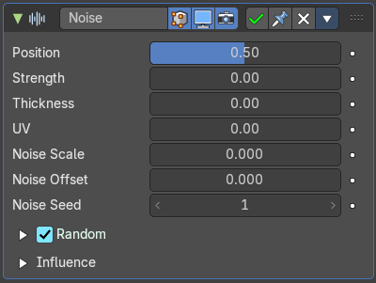
Noise
The Noise Modifier adds noise to make the grease pencil line unstable and noisy.

Position
Strength of the noise effect over the point location.

Strength
Strength of the noise effect over the point strength (opacity).

Thickness
Strength of the noise effect over the point thickness.

UV
Strength of the noise effect over the point UV rotation.

Noise Scale
Control the noise frequency scale.

Noise Offset
Offset the noise along the stroke.

Noise Seed
Add a random seed.

Randomize
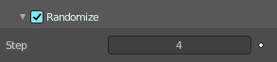
Use a random value over time.

Step
Number of frames before using a new random value.

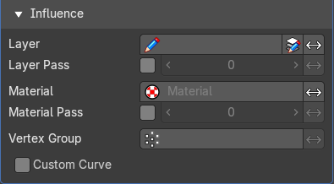
Influence subpanel

Layer
Restricts the effect only to one layer or to any layers that share the same pass index. Click to pick the layer that you want to use.

Invert
Inverts the influence.

Layer Pass
The layer pass index.

Use Layer pass
Use the layer pass.

Layer pass value
The layer pass value.

Invert
Inverts the influence.

Material
Restricts the effect only to material that share the same material or pass index. Click to pick the material that you want to use.

Invert
Inverts the influence.

Material Pass
The material pass index.

Use Material pass
Use the Material pass.

Material pass value
The Material pass value.

Invert
Inverts the influence.

Custom Curve
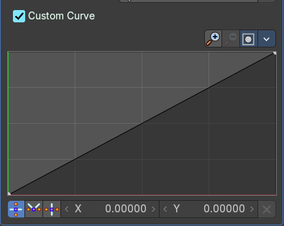
Use a custom curve to define the noise along the strokes.

Navigation elements
The navigation elements at the top are described from left to right.

Zoom in and out
The two buttons with the magnifying glass at it zooms in and out in the curve window.

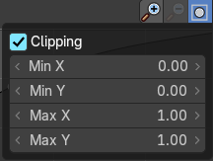
Clipping
Clipping options. Set up clipping for the stroke.

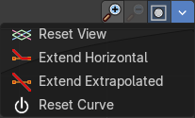
Tools
Tools is a menu where you can find some curve related tools.

Reset View
Resets the curve windows zoom.

Extend Horizontal
Extend the curve points horizontal before the first curve point and after the last curve point.

Extend Vertical
Extend the curve points vertical before the first curve point and after the last curve point.

Reset Curve
Resets the curve to the initial shape.

Curve window
Tweak and adjust the falloff curve by clicking at a curve point and dragging it around.
Double click adds a new point.
Holding down ctrl activates temporary snapping.
Holding down shift enables slower movement, which allows more accurate setting.

Vector Handle
Set handle type to Vector.

Auto Handle
Set handle type to Auto.

Auto Clamped Handle
Set handle type to Auto Clamped.

X / Y
The position of the currently selected curve point.

Delete Points
Deletes selected curve points.

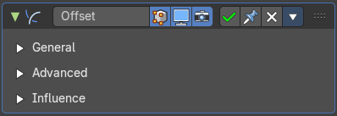
Offset
The Offset Modifier changes the strokes location, rotation or scale, starting from the object origin.

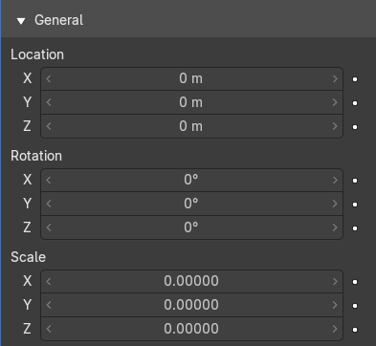
General Subpanel

Location X, Y, Z
Sets strokes location offset from its object origin.

Rotation X, Y, Z
Sets strokes rotation.

Scale X, Y, Z
Sets strokes scale.

Advanced Subpanel

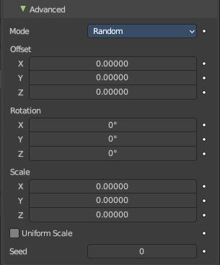
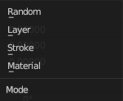
Mode

Random
Randomize Stroke Offset.

Layer
Offset Layers by the same factor.

Stroke
Offset stroke by the same factor based on stroke draw order.

Material
Offset materials by the same factor.

Offset
Randomize the offset in x y and z axis.

Rotation
Randomize the rotation in x y and z angle.

Scale
Randomize the size in x y and z axis.

Uniform Scale
Mode random. Use the same random seed for each scale axis for a uniform scale.

Seed
Mode Random. The random seed for the uniform scale.

Layer Step
Mode Seed. Number of elements that will be grouped.

Layer Offset
Mode Seed. Offset Starting Point.

Stroke Step
Mode Stroke. Number of elements that will be grouped.

Stroke Offset
Mode Stroke. Offset Starting Point.

Material Step
Mode Material. Number of elements that will be grouped.

Material Offset
Mode Material. Offset Starting Point.

Influence subpanel

Layer
Restricts the effect only to one layer or to any layers that share the same pass index. Click to pick the layer that you want to use.

Invert
Inverts the influence.

Layer Pass
The layer pass index.

Use Layer pass
Use the layer pass.

Layer pass value
The layer pass value.

Invert
Inverts the influence.

Material
Restricts the effect only to material that share the same material or pass index. Click to pick the material that you want to use.

Invert
Inverts the influence.

Material Pass
The material pass index.

Use Material pass
Use the Material pass.

Material pass value
The Material pass value.

Invert
Inverts the influence.

Shrinkwrap
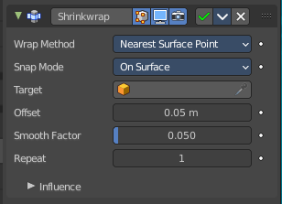
Shrinks the geometry to the surface of another object.

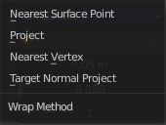
Wrap Method
The method to determine the nearest point on the target’s surface for each vertex of the object.

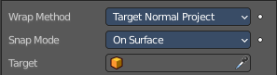
Nearest Surface Point + Target Normal Project
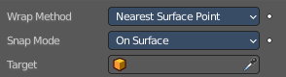
Nearest Surface Point selects the nearest point at the surface. Additionally, Target Normal Project tries to match the interpolated normals of the surface.

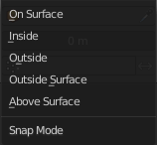
Snap Mode
How the vertex snaps to the surface. The methods should be self explaining.

Target
The target mesh to shrink to.

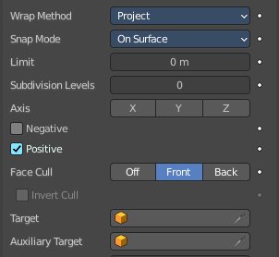
Project
Projects all vertices along a chosen axis until they hit the surface of the target object.
Vertices that never hits the surface are not calculated.

Snap Mode
How the vertex snaps to the surface. The methods should be self explaining.

Limit
A distance limit between original vertex and surface. If the distance is larger than this limit vertex would not be projected onto the surface.

Subdivision Levels
This applies a (temporary) Catmull-Clark subdivision to the modified object’s geometry, before computing the wrap.

Axis
Along which local axis of the modified object the projection is done. These options can be combined with each other, yielding a “median axis” of projection. If none are selected, the normal direction is used.

Negative/Positive
This allows you to select the allowed direction(s) of the shrink along the selected axis. If both options are enabled, both ways are evaluated and the closest hit is selected.

Face Cull
Allows you to prevent any projection over the “front side” or the “back side” of the target’s faces. The “side” of a face is determined by its normal.

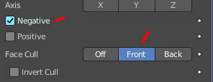
Invert Cull
When projecting in the negative direction then invert culling.
You need to have negative ticked and face cull either front or back to set this property active.

Target
The target mesh to shrink to.

Auxiliary Target
An additional object to project to.

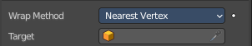
Nearest Vertex

Target
The target mesh to shrink to.

Offset
An offset distance to keep to the target surface.

Smooth factor
Amount of smoothing to apply

Repeat
Number of steps to apply smooth.

Vertex Group
Restrict the affected vertices to a vertex group.

Invert
Inverts the influence of the selected vertex group.

Influence subpanel

Layer
Restricts the effect only to one layer or to any layers that share the same pass index. Click to pick the layer that you want to use.

Invert
Inverts the influence.

Layer Pass
The layer pass index.

Use Layer pass
Use the layer pass.

Layer pass value
The layer pass value.

Invert
Inverts the influence.

Material
Restricts the effect only to material that share the same material or pass index. Click to pick the material that you want to use.

Invert
Inverts the influence.

Material Pass
The material pass index.

Use Material pass
Use the Material pass.

Material pass value
The Material pass value.

Invert
Inverts the influence.

Smooth
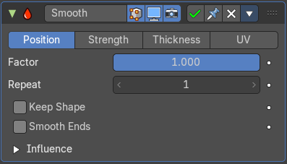
The Smooth modifier smoothens a stroke.

Mode
What elements to affect.

Position
Affects the position of the point.

Strength
Affects the color strength of the point

Thickness
Affects the thickness of the point.

UV
Affects the uv rotation factor of the point.

Factor
The smoothing amount. Higher values will increase the effect. Values outside expected range (above 1.0 or below 0.0) will distort the mesh.

Repeat
The number of smoothing iterations.

Keep Shape
Smooth the details, but keep the overall shape.

Smooth Ends
Smooth the ends of strokes.

Influence subpanel

Layer
Restricts the effect only to one layer or to any layers that share the same pass index. Click to pick the layer that you want to use.

Invert
Inverts the influence.

Layer Pass
The layer pass index.

Use Layer pass
Use the layer pass.

Layer pass value
The layer pass value.

Invert
Inverts the influence.

Material
Restricts the effect only to material that share the same material or pass index. Click to pick the material that you want to use.

Invert
Inverts the influence.

Material Pass
The material pass index.

Use Material pass
Use the Material pass.

Material pass value
The Material pass value.

Invert
Inverts the influence.

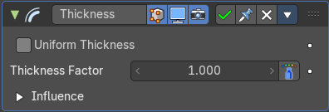
Thickness
The Thickness Modifier change the stroke points thickness.

Uniform Thickness
When enabled, makes the thickness equal for the entire strokes.

Thickness Factor
Value to add or subtract to the actual points thickness.

Weighted
Use weight to modulate effect.

Influence subpanel

Layer
Restricts the effect only to one layer or to any layers that share the same pass index. Click to pick the layer that you want to use.

Invert
Inverts the influence.

Layer Pass
The layer pass index.

Use Layer pass
Use the layer pass.

Layer pass value
The layer pass value.

Invert
Inverts the influence.

Material
Restricts the effect only to material that share the same material or pass index. Click to pick the material that you want to use.

Invert
Inverts the influence.

Material Pass
The material pass index.

Use Material pass
Use the Material pass.

Material pass value
The Material pass value.

Invert
Inverts the influence.

Custom Curve
Use a custom curve to define the noise along the strokes.

Navigation elements
The navigation elements at the top are described from left to right.

Zoom in and out
The two buttons with the magnifying glass at it zooms in and out in the curve window.

Clipping
Clipping options. Set up clipping for the stroke.

Tools
Tools is a menu where you can find some curve related tools.

Reset View
Resets the curve windows zoom.

Extend Horizontal
Extend the curve points horizontal before the first curve point and after the last curve point.

Extend Vertical
Extend the curve points vertical before the first curve point and after the last curve point.

Reset Curve
Resets the curve to the initial shape.

Curve window
Tweak and adjust the falloff curve by clicking at a curve point and dragging it around.
Double click adds a new point.
Holding down ctrl activates temporary snapping.
Holding down shift enables slower movement, which allows more accurate setting.

Vector Handle
Set handle type to Vector.

Auto Handle
Set handle type to Auto.

Auto Clamped Handle
Set handle type to Auto Clamped.

X / Y
The position of the currently selected curve point.

Delete Points
Deletes selected curve points.

